(Your logo here)
PRE EVALUATION POST EVALUATION

Informed Consent

You have been asked to participate in a Functional Capacity Evaluation which is a series of tests including strength, range of motion and cardio, that takes place in 2 to 4 hours and is used to help determine your safe abilities to perform work related activities.

Testing includes some or all the following tasks:

o Medical History
o Physical Exam
o Cognitive Assessment
o Measurement of Range of Motion
o Measurement of Back Strength
o Grip and Pinch Strength
o Special Tests related to your Diagnosis
o Lifting, Carrying, Pushing and Pulling
o Functional activities such as walking, standing, sitting, bending, reaching, crouching, kneeling, stooping, handling & fingering.

Each test is voluntary, and you may refuse any test if you feel you are unable to perform it. We ask that you provide the evaluator with honest feedback as to how you are doing as it relates to pain, fatigue and any other symptoms you may have. We ask for your cooperation to provide your best, safe effort with each of the functional tasks.

There are risks for injury during the FCE. You may experience an increase in your pain, an aggravation to your existing injury or a new injury. The tests are considered safe and acceptable if you do not permit your pain to increase significantly throughout the testing.
Therefore, it is important that you do the following:
1. Report any pain increases immediately.
2. Do not perform any test you do not feel you are able to perform.
3. Do not allow your pain to increase significantly during testing.

Your evaluator will stop any test if you appear to be over stressing yourself. You will not be forced to perform any test you feel you are not able to perform; you should stop any test if your pain significantly increases.

As with any physical exertion there is some risk for injury. Your evaluator will take every precaution to ensure your safety. Some soreness is not unusual a day or two after testing. If you have any questions, please feel free to ask your evaluator. If you have any concerns that require immediate attention, please contact your physician or local emergency room.

By affixing your signature below, it implies that you have read the above information and have had any questions you might have answered fully. Your signature also implies permission for digital images to be taken to supplement the report and confirm your identification and functional abilities. We will make every effort possible in collecting fees due from the insurance organization provided. Should this not be possible then the fees due are the sole responsibility of the client evaluated. I agree not to hold the clinic or staff responsible for any damage that may occur during the FCE process and I understand the above information and I agree to participate in the Functional Capacity Evaluation to the best of my ability to help determine my ability to work.

Client: (sign) _________________________ Date _____________________(print) _________________________

Legal representative (if applicable): _______________________________________________________________

Evaluator: _________________________ Date _____________________

(your clinic address and contact information here)

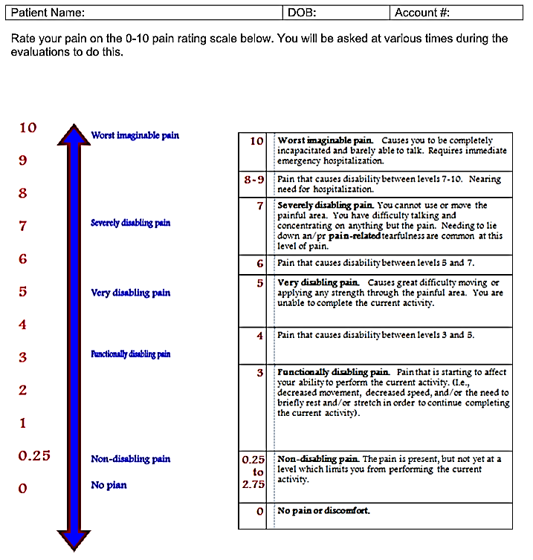

There are many words that describe pain. Some of these are group below. Look at each group of words and circle any word which describes the pain you are experiencing RIGHT NOW. Continue until you have finished all 20-word group. You should choose only one word from every word group, but you do not have to choose a word from every word group. If none of the words in a particular word group describes your pain, go to the next word group.
